Irevolution: A Data-Driven Exploration of Apple's iPhone Impact in India
Team leader: Pavithra.R
Team memebers:
1)Pavithra.R
2)Padmapriya.R
3)Pavithra.R
4)Padmavathi.S

Introduction:
The rise of smartphones has revolutionized the way people across the globe communicate access information and conduct business. Among the many smartphone brands Apple's iPhone has garnered significant attention and popularity. India with its vast population and growing middle class has emerged as a crucial market for smartphone manufacturers including Apple. This article aims to explore the impact of Apple's iPhone in India analyzing data and trends to provide an in-depth understanding of its significance in the country.

Empathy map:

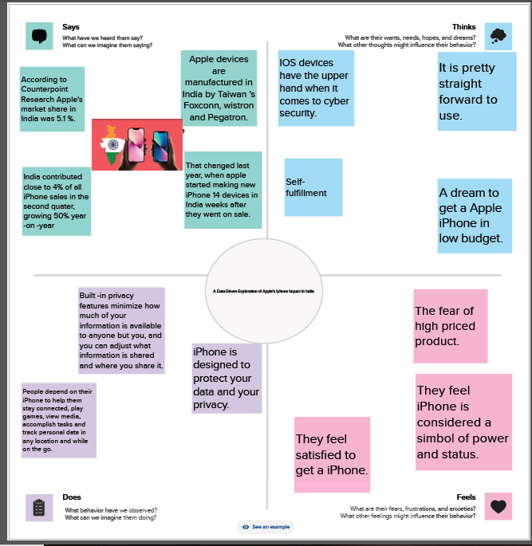

Brainstorming:
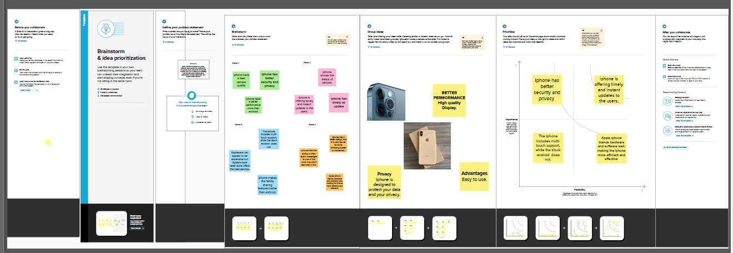
KPI:
Key performance indicators include customer satisfaction, employee alignment and commitment , market share and shareholder value.


Model specification:
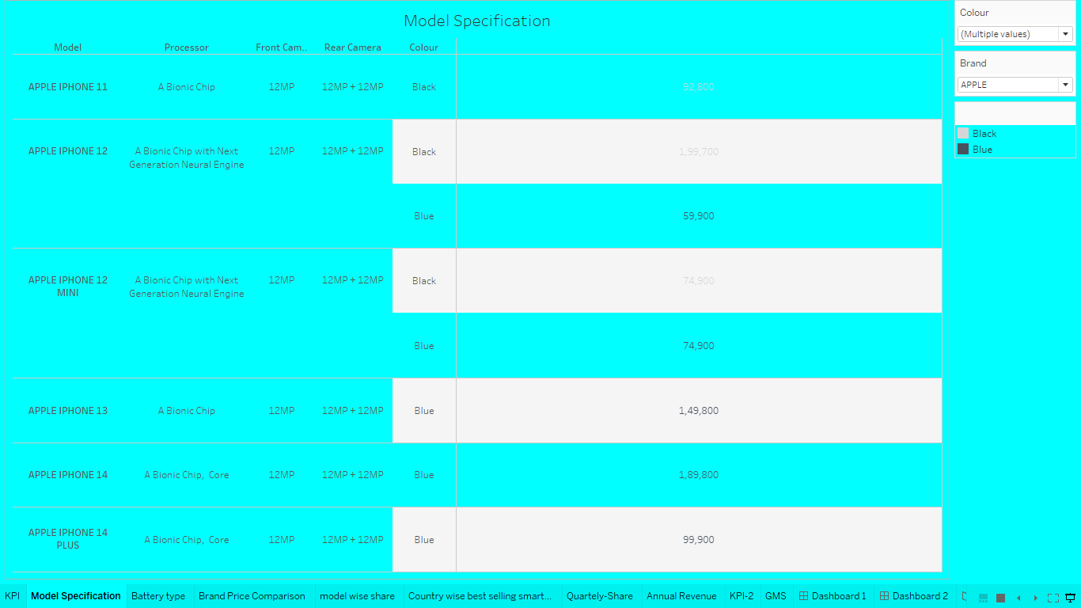

Battery type distribution:
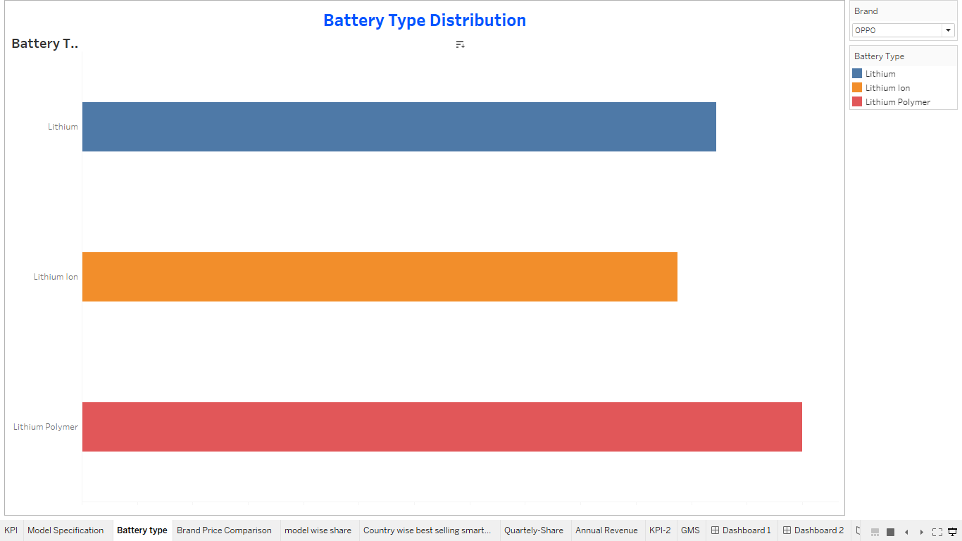

Brand price comparison:
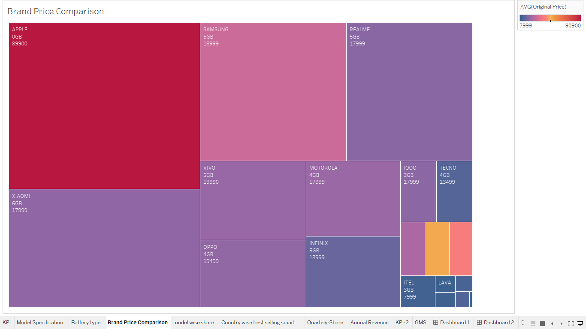

Model wise share:
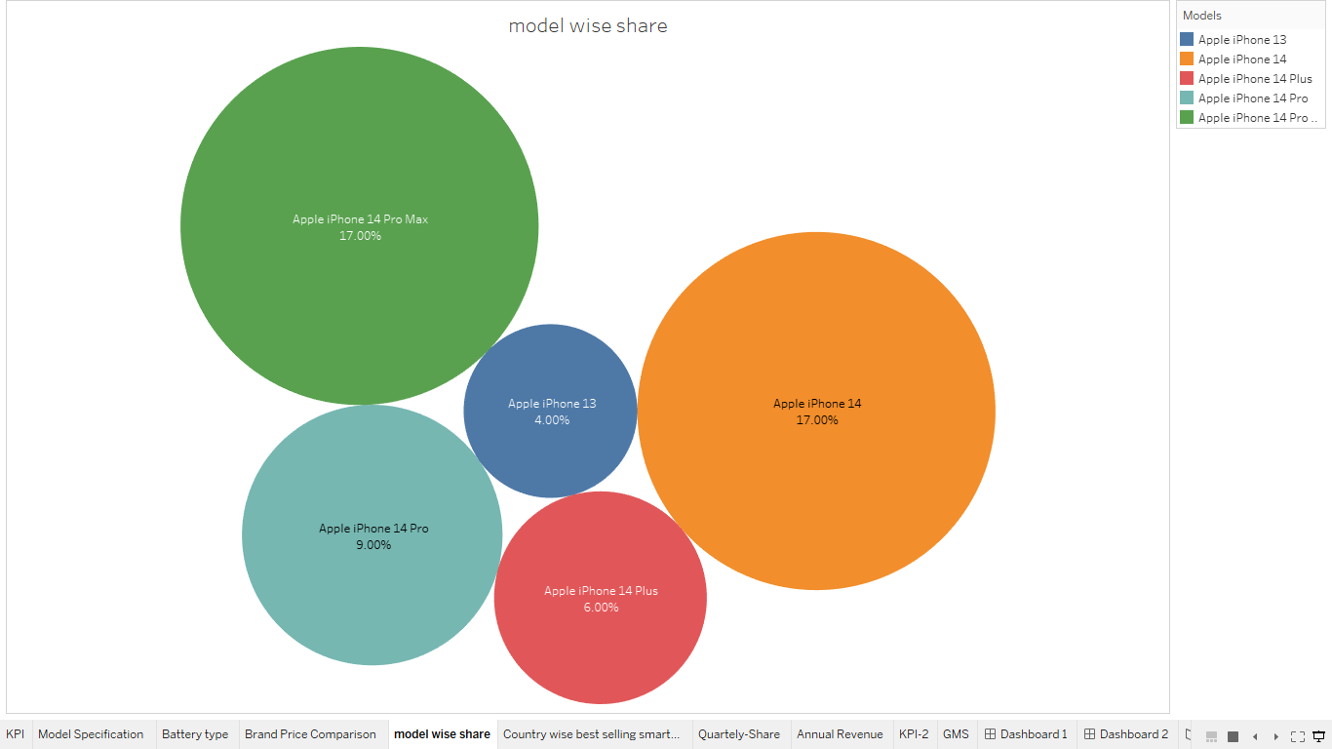

Country wise best selling smartphone:
comparative analysis amongst various other reading brands in the smart phone industry shows. Iphone is yet to make it's impact in India.
